

MATES Computer Science

**Senior Capstone Project Bi-Weekly Progress Report**

| Project Title | Empoint |
| --- | --- |
| Team Members | Keith Sawyer |
| Dates Covered by Report | May 3 - May 17 |
| Link to Github | <https://github.com/keithstuff/3DPlatformerCapstone> |

# **Summary of Project** (Provide a one paragraph summary of your project. You can largely copy/paste this from one progress report to the next, unless there are significant changes.)

I plan to create a 3D puzzle platformer using the game engine Godot. The game will consist of enjoyable platforming based on titles such as “A Hat in Time” and “Mario Odyssey”. The premise of the game is lighting up the level by interacting with towers that emit light. As the player lights up more towers, more of the map will be revealedI plan to make, at the very least, a tech demo for the platforming and puzzle interaction mechanics, and at the most 3-4 interesting levels. The models for the game, such as the player character and props, will be modeled in Blender.

# **Summary of Progress this Period** (Provide a high-level, one paragraph overview of what was accomplished this progress period collectively by the team.)

As the final progress report has drawn ever closer, I’ve worked these past two weeks to ensure that the game is a complete experience. It may not be the ambitious vision I had envisioned when I first sat down and brainstormed for it, but the game itself is somewhat in a “complete” state. If a player were to boot up the game, they would be able to play it fully, despite it still feeling like the bare bones of a game.

# **Detailed Progress this Period, separated by Team Member** (Provide detailed information on the progress that you made in the reporting weeks. Include screenshots of code, your game or website, etc. Each team member should have a separate subsection covering their accomplishments. Not including screenshots, this section should be 1-2 pages.)

I spent the past two weeks finishing up the ending animation for the game when the player completes the level, adding textures to the level to make it feel a little more alive, and working on UI. In my last progress report I mentioned an issue I was having with getting the player character to interact with an outside gravity force from the “Area3D” around the black hole at the end of the level. I ended up going with the simple solution, which was to instead tween the position of the character from where it was standing to the center of the blackhole over the course of a few seconds. For an added effect, I also made the character shrink as they grew nearer to the black hole, which I think is a nice extra touch.

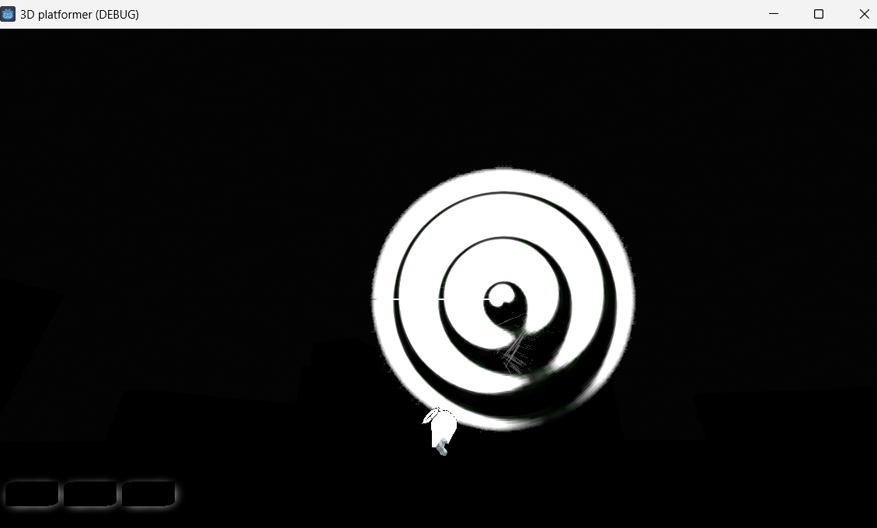

After I had finished the black hole I realized that after the player reaches it, the character falls back down to the ground and the game just awkwardly sits there. To rectify this, I added an endscreen that shows when the character reaches the black hole that displays in a clean font “STAGE CLEARED” and the time it took for the player to complete the stage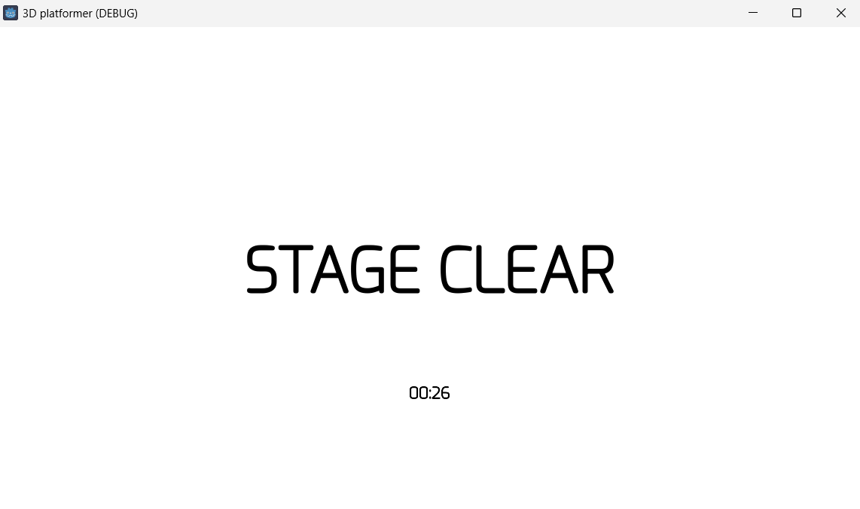

*Note you cannot complete the level in only 26 seconds. I added a button that lets me force the level to complete for testing purposes

After adding this UI addition for the end of the game, I worked on adding some grass to the scene to make the game area feel less empty. This took me a bit of time to properly get working. I ended up finding a free shader online that someone had made to simulate swaying grass. I used it to generate little grass patches around the floor. I also used a free online texture I found on the floor to give it a sandy/ground look. Initially it looked terrible because the texture was stretched out across the entire surface of the floor. I found a way to make the texture repeat itself across the floor, which made it look a little better and more high definition. If I had more time I would spend it working on the textures for the area, but I had to move on to the next thing, which was a main menu for the game.

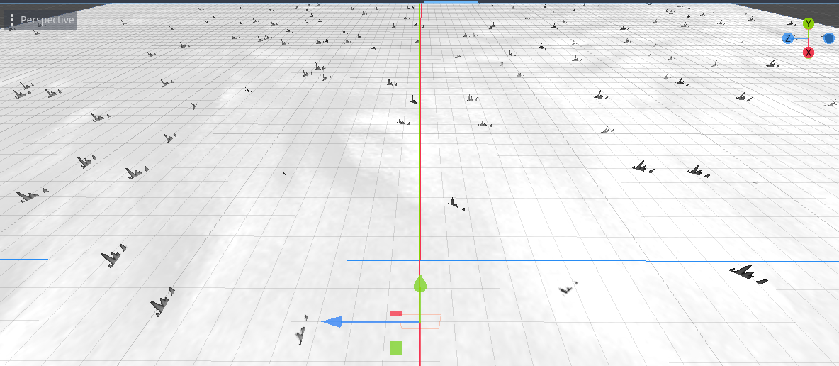

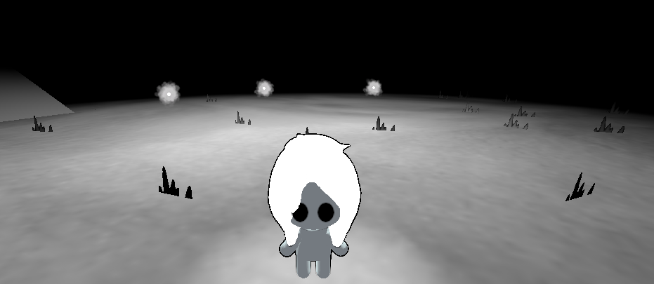

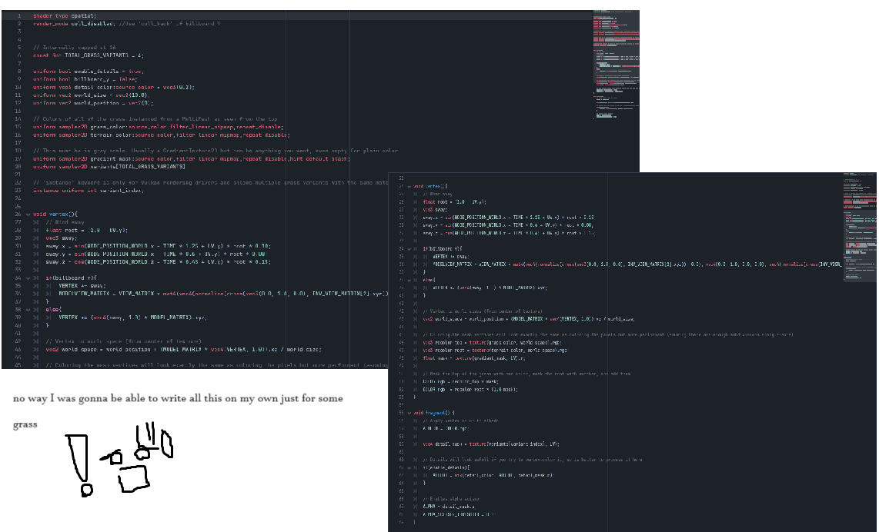

Even after taking the online grass shader, it took me a day of toggling with all of its features for me to figure out how to get it to propagate across the floor surface. When I finally figured it out I was somewhat angry with myself for how easy it was. I’ll write a little excerpt for the “problems” document but basically I just had to click this button: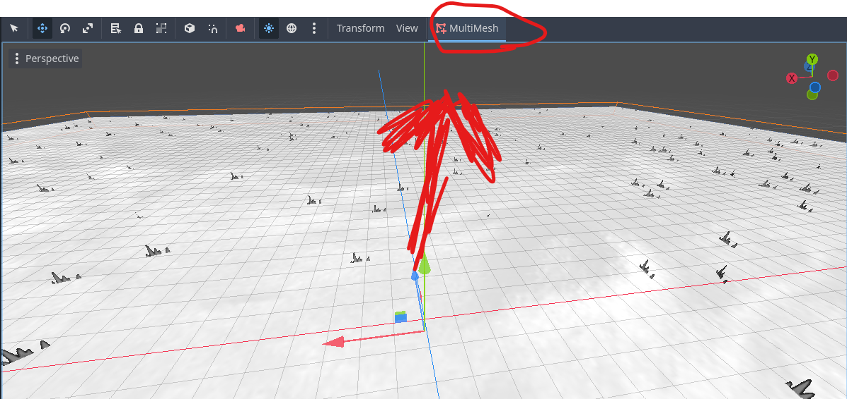

I created a main menu for the game that simply has a play button that sends the player to the level. I had an idea to make the menu a sort of 3D area that moved around and panned when the user moved their mouse, but I didn’t have enough time to implement it. Instead I went with this clean and simple design. I used bing AI to generate a little swirly white flame logo for the game, which I placed under the title. The button is fully functional and does send you to the next level, but I worry that when it does the level won’t be loaded all the way. I want to add a loading screen that plays when you press the button to give the level time to load in before the player is able to start moving around.

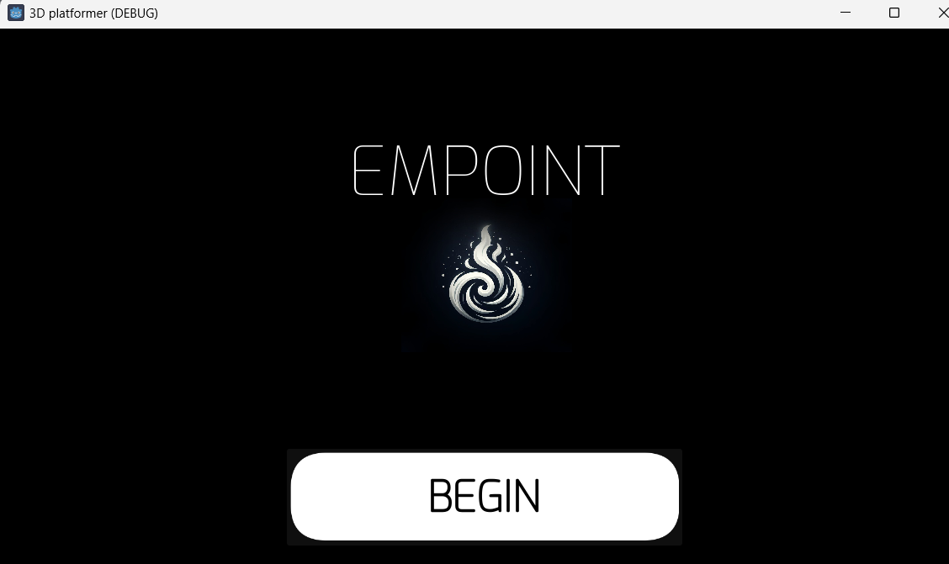

# **Updated Trello Board and Discussion** (Provide screenshot of and link to updated Trello board. Discuss any changes made to board since last progress report and why.)

https://trello.com/b/wh23rsoC/3d-platformer-keith-sawyer

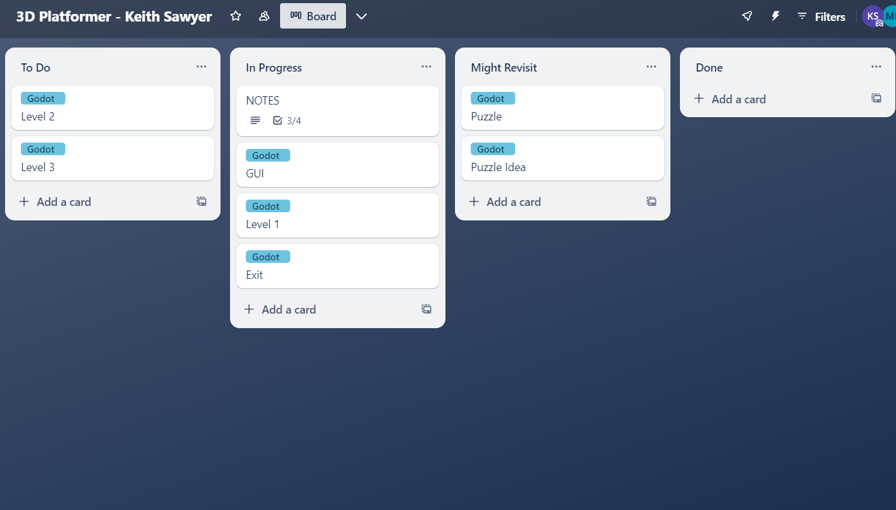

I archived the completed cards from the last two weeks and moved ”GUI,” “Level 1,” and “Exit,” over to the “In Progress” list.

# **Tasks to Be Worked on in Next Progress Period** (Discuss the tasks to be worked on in the following two weeks. Discuss who is working on each.)

I plan to put the absolute final touches to the game, which includes sound, music, and maybe a loading screen if I can get to it. I really want there to be sounds in the game, and that is something I can actually work on at home as well, so I should be able to finish that before the final demonstration of the game.

# **Additional Information** (Provide any additional information that you want to provide in this section; for example, one of your teammates is going away next week, your Github account is gone, etc. It could be good news as well.)